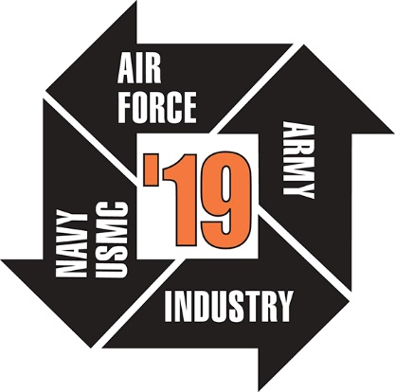

In addition to the original application, applicants MUST submit:
- RESUME or CURRICULUM VITAE (both teacher and administrator)
- PERSONAL STATEMENT which addresses the following questions:
  - Why do you feel STEM/STEAM education and in particular modeling and simulation are important?
  - What are some current ways you are involved with STEM technology, specifically modeling and simulation, in your teaching?
  - What are your goals for participating in America’s Teachers and in what ways do you feel your participation will help you become a more effective teacher and in turn benefit your students?
  - How will the I/ITSEC conference experience and ongoing relationship with America’s Teachers Alumni support your professional growth, classroom instruction, and school district?
  - How do you plan on sharing your experiences and classroom applications with your colleagues?
- LETTER OF RECOMMENDATION from an administrator/supervisor/coach in your current school (the person that would be attending I/ITSEC with you)
- A Modeling and Simulation lesson you designed and have implemented in your classroom; a STEM/STEAM lesson is acceptable if you are new to Modeling and Simulation

Additional Follow-Up Commitments
➔ Submit an electronic copy of the notes and/or presentation that you used to share your I/ITSEC experiences and Modeling and Simulation classroom applications with your colleagues.
➔ Stay connected with I/ITSEC America’s Teachers Alumni.

